SCREENSHOTS OF RAILWAY RESERVATION SYSTEM FRONTEND:

1.HOME PAGE:

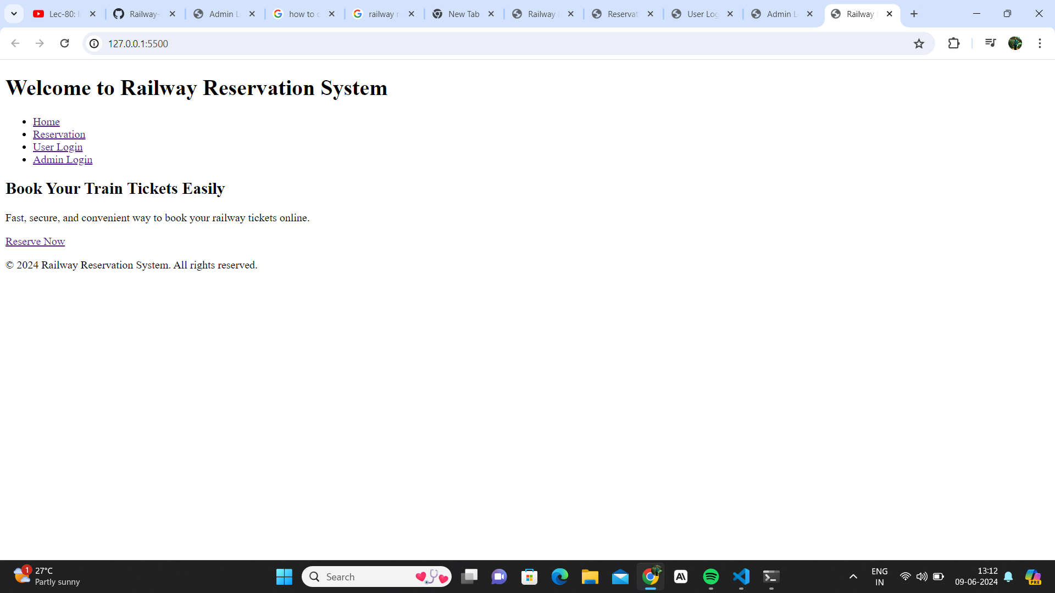

2.RESERVATION PAGE:

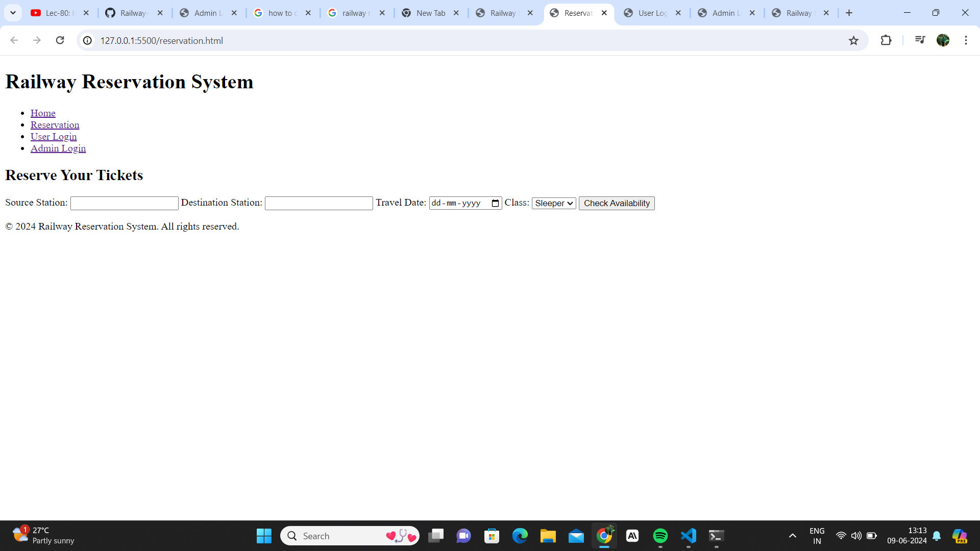

3.USER LOGIN PAGE:

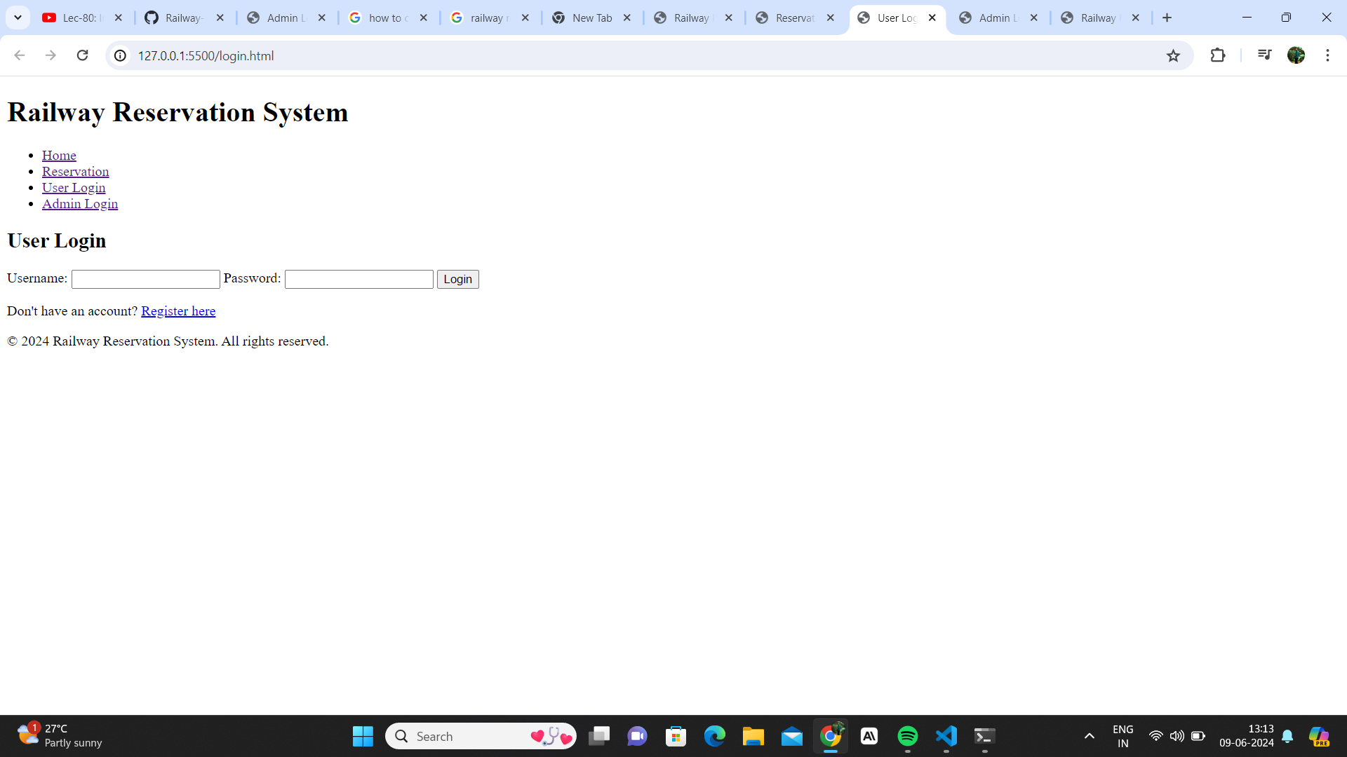

4.ADMIN LOGIN PAGE:

